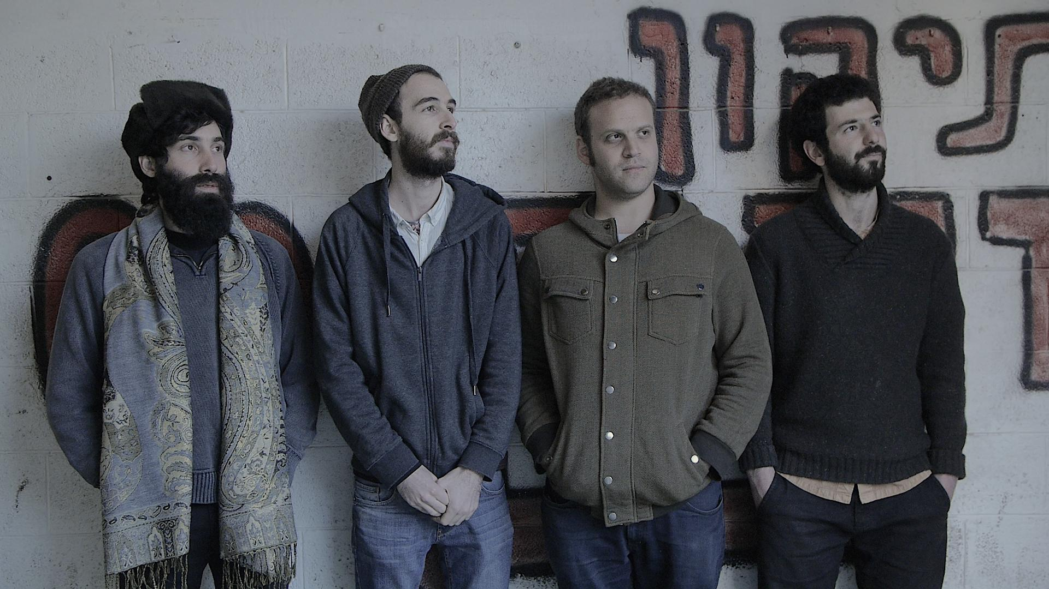

Katamon Cherry is an electric instrumental quartet. Four distinct personalities blend intricate compositions with fearless improvisation, centered by powerful groove. Growing up together in the Jerusalem neighborhood of Katamon has cemented a deep friendship between the band members, which is felt in the music. This history creates a special atmosphere on stage adding further dimensions to the listener’s experience.

Elad Gellert - Saxophon,
Adam Weingrod - Guitar,
David Hai Michaeli - Bass,
Haim Peskoff - Drums

